**Computer organization and Assembly language**

**Assignment # 5**



**NAME: RABIA KHAN**

**CLASS: BSCS(3G)**

**ROLL NO: BCSM-F20-349**

**Submitted To: Mr. Noman**

**Question no.1**

What is the main purpose of shift left double instruction? Explain with example.

Answer:

Shift left double instruction is used to shift most significant bits of the source on the destination least significant bits. It transfers a complete hexadecimal number. The destination operand is modified, but the source operand remains same.

The main purpose of shift left double instruction is that it shifts 4 bits (a single hexa number) at a time to the left on the least significant bit of the destination.

Syntax:

SHLD destination, source, count

Example:

Org 100h

Mov ax,7C36h ; ax=7C36h

Mov dx,9FA6h ;dx=9FA6h

SHLD ax, dx,4 ; shift 4 bits of the source towards the destination

Answer:

Dx=9FA6h ; Source is not modified

Ax=C369h ; destination is modified

Question no.2

What is the main purpose of shift right double instruction? Explain with example.

Answer:

Shift right double instruction is used to shift most significant bit of the source to the least significant bits of the destination. It transfers a complete hexadecimal number. The destination operand is modified, but the source operand remains same.

The main purpose of shift right double instruction is that it shifts 4 bits (a single hexa number) at a time to the right on the least significant bit of the destination.

Example:

Org 100h

Mov ax,7C36h ;ax=7C36h

Mov dx,9FA6h ;dx=9FA6h

SHRD ax,dx,4 ; shift 4 bits of source towards the destination

Answer:

Dx=FA67h ; destination is modified

Ax=67C3h ; source is not modified

Question no.3

Shifting bits within array.

Answer:

Org 100h

.data

Arrsize equ 7 ; constant

Arr db Arrsize dup (18) ; dup operator intilize an array of 7 size

.code

Mov ax,@data

Mov ds,ax

Mov cx,Arrsize ; cx=7

Mov si,0 ; si=0

Clc ; clear carry

L1:

Rcr arr[si],1 ; rotate carry left it divide the number by 2

Mov al,arr[si] ; al=arr[si]

Add al,30h ; for Integer input

Mov ah,2 ; output intrupt

Int 21h

Inc si ; si=si+1

Loop l1 ; loop end

Mov ah,4ch ;program ends

Int 21h

Output:

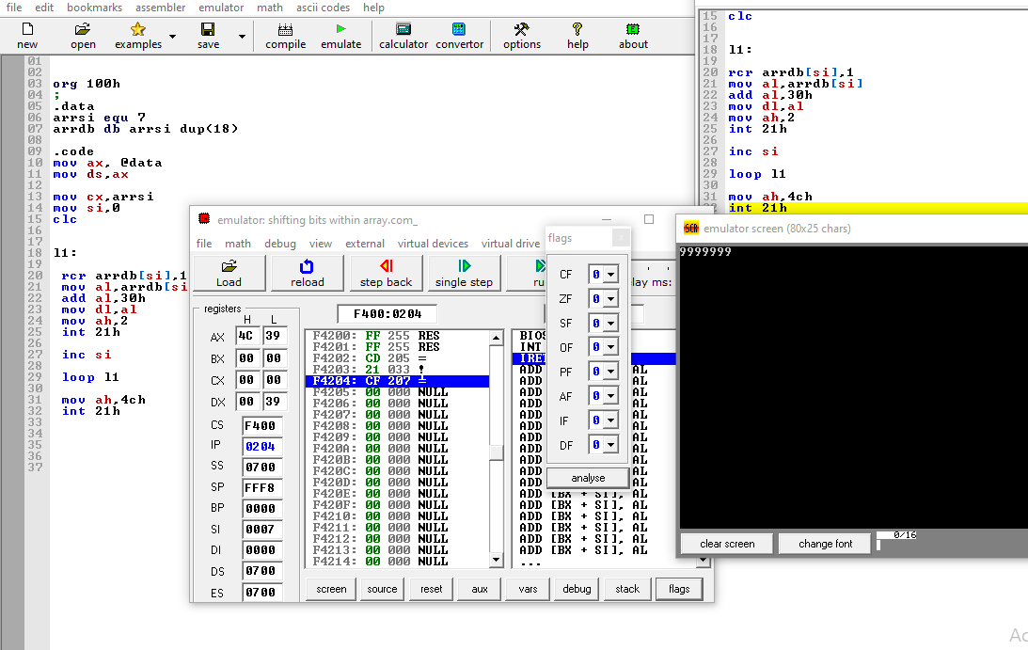

Question no.4

Write an example of binary multiplication?

Answer:

Org 100h

Mov ax,2 ;ax=2

Mov bx,ax ;bx=2

Shl ax,2 ; ax=2*2*2=8

Shl bx,5 ; bx=2*2*2*2*2*2=64

Add ax,bx ;ax=ax+bx=8+64=72

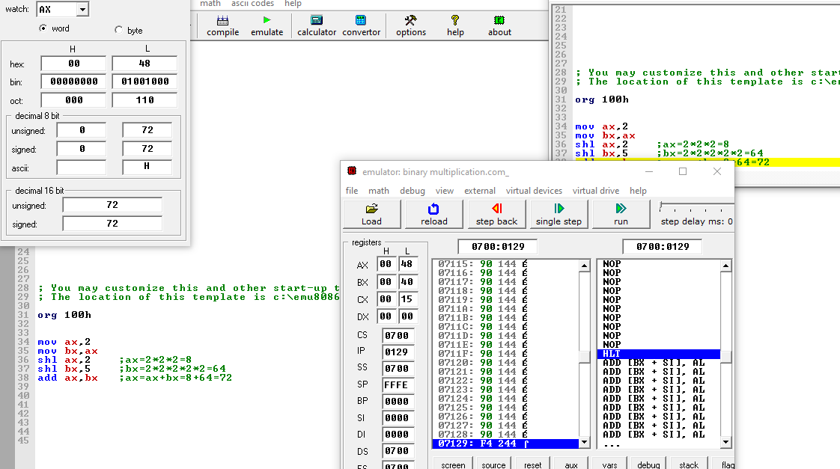

Question no.5

Convert number to binary and hexa string?

Answer:

Question no.6

What is the main difference between mul and imul instructions? Explain with example.

The difference between mul and imul is that mul is used to for the multiplication of unsigned integers. But imul is used for the multiplication of signed integers.

Example: Mul

Org 100h

Var1 dw 3

Var2 dw 3

Mov ax,var1

Mul var2

Add ax,30h

Mov dx,ax

Mov ah,2

Int 21h

Mov ah,4ch

Int 21h

Output:

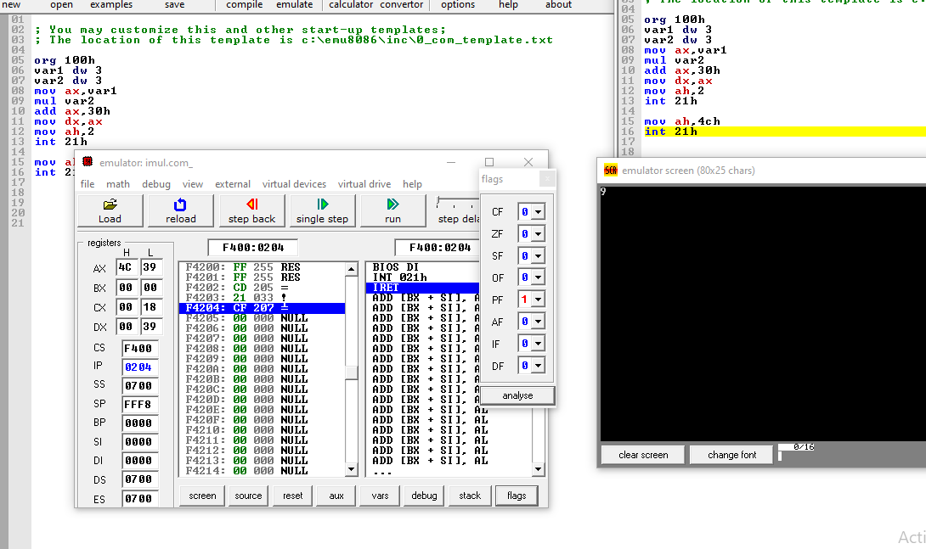

Example: imul

Org 100h

Var1 dw -3

Var2 dw -3

Mov ax,var1

imul var2

Add ax,30h

Mov dx,ax

Mov ah,2

Int 21h

Mov ah,4ch

Int 21h

Output:

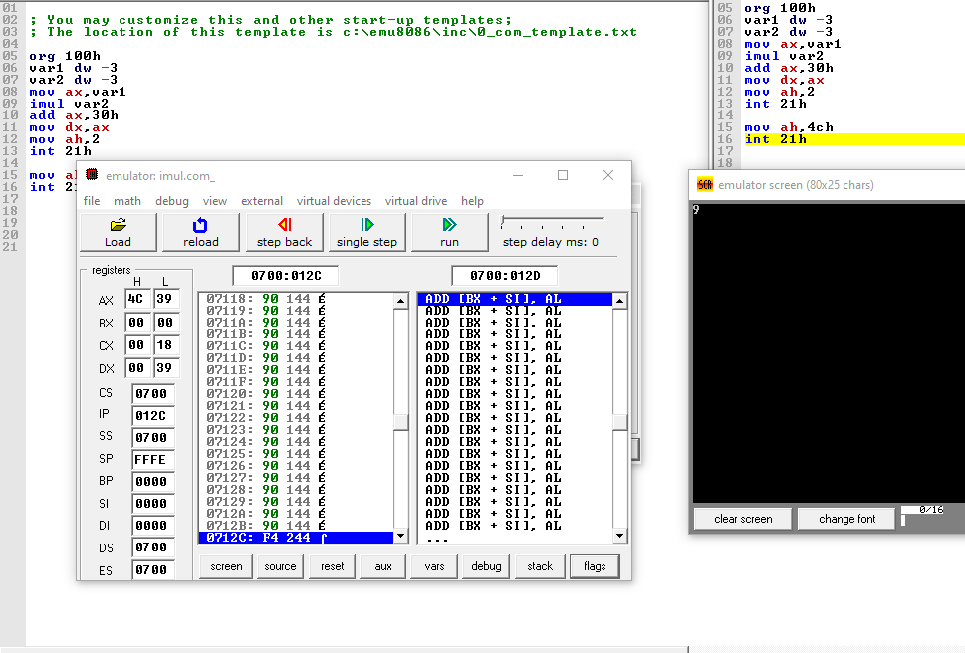

Answer:

Question no.7

Answer:

What is the main difference between div and idiv instructions? Explain with example.

The difference between div and idiv is that div is used to for the division of unsigned integers. But idiv is used for the division of signed integers.

Example: div

Org 100h

Mov ax,10

Mov bx,2

Div bx

Add ax,30h

Mov dx,ax

Mov ah,2

Int 21h

Mov ah,4ch

Int 21h

Output:

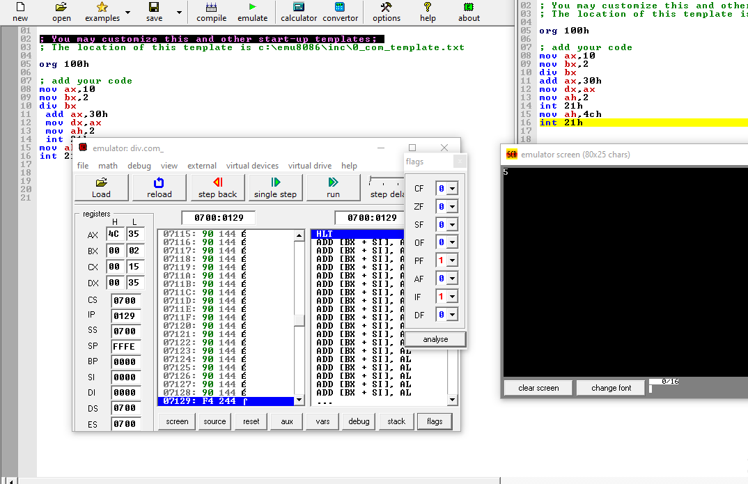

Example: idiv

Org 100h

Mov ax,-10

Mov bx,-2

idiv bx

Add ax,30h

Mov dx,ax

Mov ah,2

Int 21h

Mov ah,4ch

Int 21h

Output:

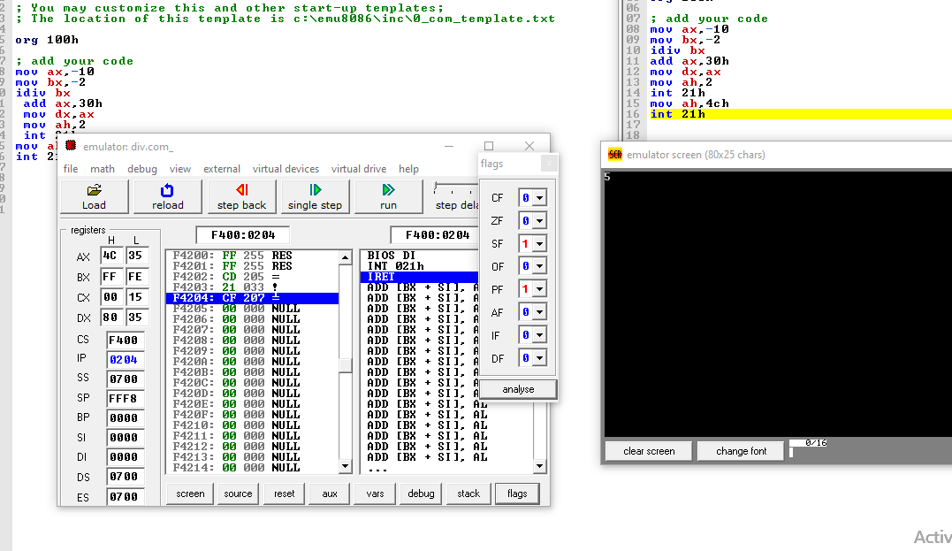

Question no.8

What is 2 and 3 operands format?

Answer:

Two operand

Mov ax,4 ; ax=4

Mov bx,2 ; bx=2

Mul ax,bx ;ax=ax*bx=4*2=8

Add ax,30h ; for integer ouput on the console

Mov dx,ax ; for output of the result of multiplication

Mov ah,2 ; for the ouput interrupt

Int 21h

Mov ah,4ch

Int 21h

Three operand format

Mov ax,2 ; ax=2

Mov bx,2 ; bx=2

Imul bx,ax,4 bx=ax*4=2*4=8

Add bx,30h

Mov dx,bx

Mov ah,2

Int 21h

Mov ah,4ch

Int 21h

Question no.9

Convert decimal string to number?

Answer:

Question no.10

Convert number to decimal string?

Answer:

Question no.11

Explain difference between LOOPZ and the LOOPE?

Answer:

Loopz Example

Org 100h

.data

Arr db 1,2,3,4

.code

Mov ax,@data

Mov ds,ax

Mov cx,4

Mov si,offset arr

Loop1:

Mov ax,[si]

Add ax,30h

Mov dx,ax

Mov ah,2

Int 21h

Inc si

Loopz loop1

Mov ah,4ch

Int 21h

Output:

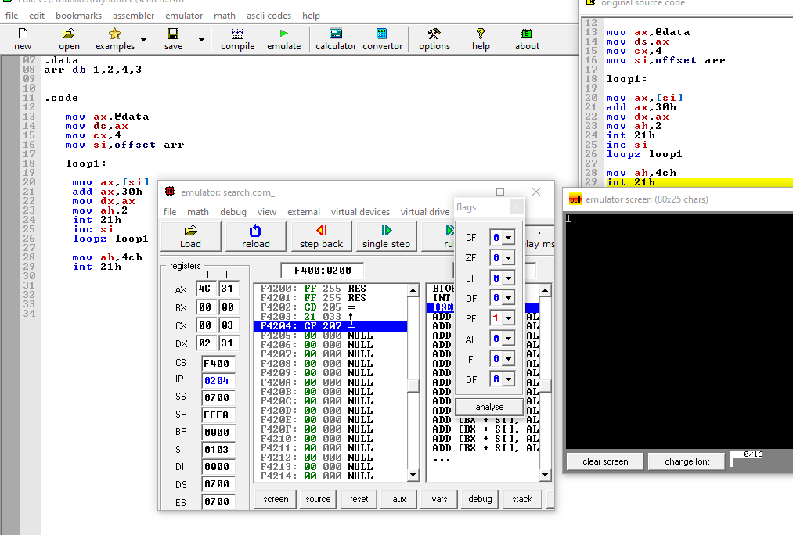

Example loope

Org 100h

.data

Arr db 1,2,3,4

.code

Mov ax,@data

Mov ds,ax

Mov cx,4

Mov si,offset arr

Loop1:

Mov ax,[si]

Add ax,30h

Mov dx,ax

Mov ah,2

Int 21h

Inc si

Loope loop1

Mov ah,4ch

Int 21h

Output:

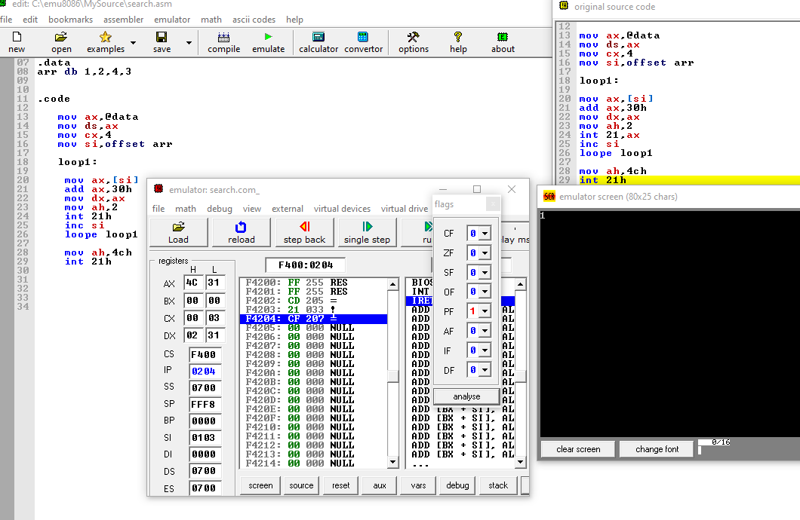

Question no.12

Explain difference between if-else and switch statement in assembly language?

Answer:

If else in assembly language is by using conditional jumps. There are unsigned and signed jumps are used. Which make a if else structure

If statement

org 100h

.data

str1 db "first number is greater $ "

str2 db "second number is greater $ "

.code

mov ax,@data

mov ds,ax

mov ah,1

int 21h

mov bl,al

mov ah,1

int 21h

cmp bl,al

jg if

jng else

else:

mov ah,2

mov dl,0dh

int 21h

mov dl,0ah

int 21h

lea dx,str2

mov ah,9

int 21h

mov ah,4ch

int 21h

if:

mov ah,2

mov dl,0dh

int 21h

mov dl,0ah

int 21h

lea dx,str1

mov ah,9

int 21h

mov ah,4ch

int 21h

output:

